Programming Instructions for Adagio Brand Motorized Roller Solar Shade
CHARGE MOTOR FULLY
Charge the motor for 4-6 hours to ensure your motor is fully charged before programming. Included in your bundle is a USB-C to USB-A Cable. Plug the USB C Charging end into the motor head. Plug the USB-A end into the charging block and plug the block into a power outlet. Leave plugged in for four to six hours to ensure your motor is fully charged. When charged, unplug the USB-A end from the outlet and then unplug the USB-C Charging end from the motor.

If you have ordered 1 shade you will receive a 1-Channel remote. If you order more than 1 shade you will receive a 6-Channel remote.
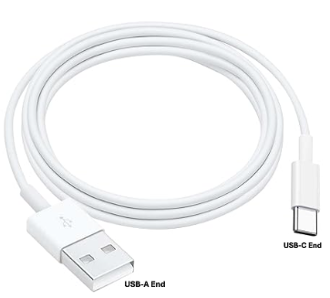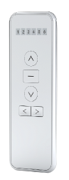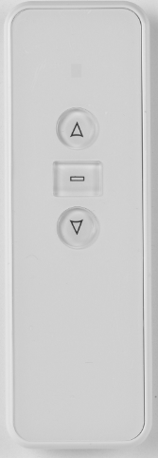
USB-A to USB-C 6-Channel Remote 1-Channel Remote

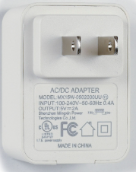
Charging Block

POWER MOTOR ON
- Turn the Power ON by pushing the PROGRAM button below the charging port for
1 second until the red light comes ON. Once the light is illuminated, the power to the motor is ON and you are ready to start programming.
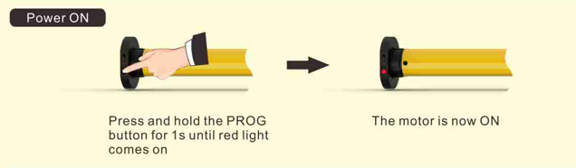
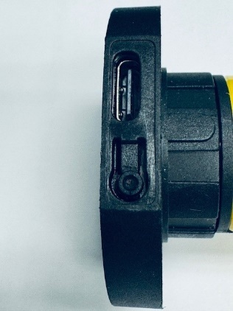
Motor Close Up

- In the event you are not ready to start programming your motor, you will need to turn the power off. To turn the Power to OFF, press and hold the PROGRAM button for 7 seconds. (The motor will jog once at 1st second) and the red light will flash 3 times. The motor is now turned off.
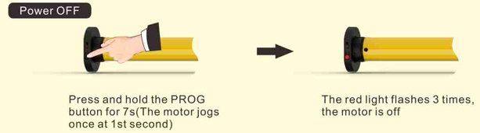

PROGRAMMING YOUR MOTOR
Make sure the motor is “on” as detailed above.
- Read ALL the instructions completely from start to finish BEFORE starting to program your shade. If there is no action in 10 seconds, the motor will exit programming automatically.

- Press and hold STOP button on 1- Channel Remote for 5 seconds. The motor will jog once. The motor is now in programming mode.
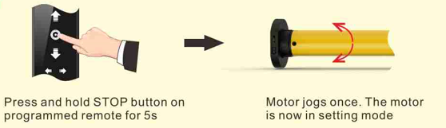

- To pair your remote with your motor so that they will start communicating with each other press the UP button. The motor will jog once. The motor and remote are now paired and are communicating.
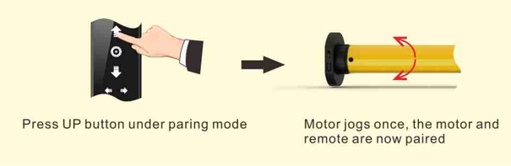

- You will now need to make sure your motor is turning in the proper direction. The shade should be rolling off the back side. If you find it is turning in the wrong direction, press the remote DOWN button and the motor will jog once. The motor direction is now reversed if you find it is turning in the wrong direction. The shade should be rolling off the back side of the shade.
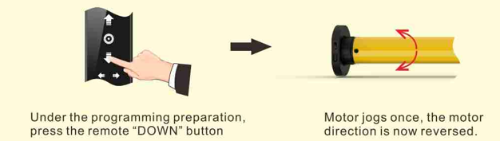
SETTING UPPER AND LOWER LIMITS
- Setting your upper limit: To set your upper limit, or where you want your shade to stop when it is raised to the top, turn your remote control over to the back side. There is a small hole in the center of the remote. You will need a small instrument (paper clip) that will fit inside the hole to push an internal button for the next steps.
- Press this button internally for 1 second. The motor will jog one time to let you know the motor is in set up mode.
- The upper limit is set by pressing the UP button on the front of the remote control until you reach the desired position of your shade. You may need to press the the button a few times between the UP and STOP button to get exactly where you want your shade to stop when raised. You will press the STOP button when you reach your desired position.
- Turn your remote control over to the back side again and insert your small instrument inside the hole in the center again and push the internal button. The motor will jog one and the upper limit is saved.
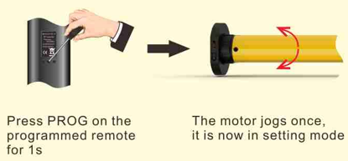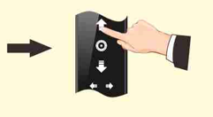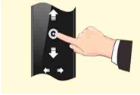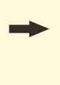
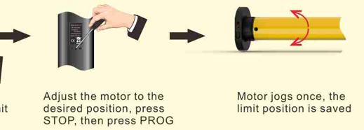

- Setting your lower limit: To set your lower limit, or where you want your shade to stop when it is lowered to the bottom, press the DOWN button on the front of the remote control until you reach the desired position of your shade. You may need to press the button a few times between the DOWN and STOP button to get exactly where you want your shade to stop when lowered. You will press the STOP button when you reach your desired position. turn your remote control over to the back side. There is a small hole in the center of the remote. You will need a small instrument that will fit inside the hole to push an internal button for the next steps.

- On the back side of the remote control press this internal PROGRAM button for 1 second. The motor will jog one time to let you know the motor is in its set up mode.
- Insert your small instrument inside the hole in the center again and push the internal button. The motor will jog once and the lower limit is saved.
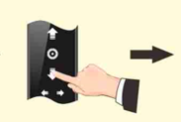
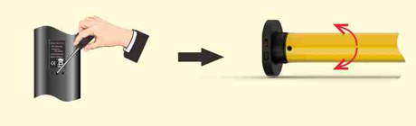
STEPS FOR THE 6-CHANNEL REMOTE
Each shade will need to be programmed with each step above on a specific channel for each shade.
Channel 1 will have shade 1 programmed individually, channel 2 will have shade 2 programmed individually and so on for however many shades you have in your room.
You will change channels by using the bottom arrows. The channel will light up on the top numbers. The channel lit up is the channel you will program, 1 shade at a time.
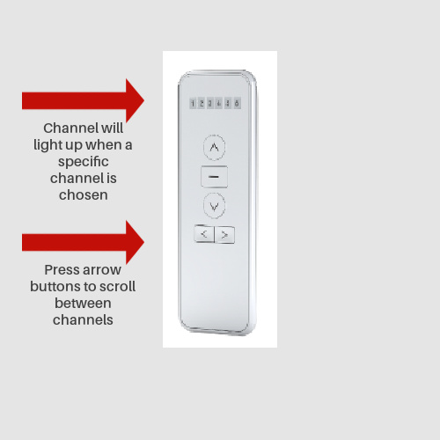
Important!! Follow the steps above to program each shade. Start from the beginning of the programming instructions for each shade on one specific channel.
You cannot program more than 1 shade on an individual channel.
Example: Shade 1 – Channel 1
Shade 2 – Channel 2
Shade 3 – Channel 3
Shade 4 – Channel 4
Shade 5 – Channel 5
Shade 6 – Channel 6

TO ADJUST LIMIT SETTINGS
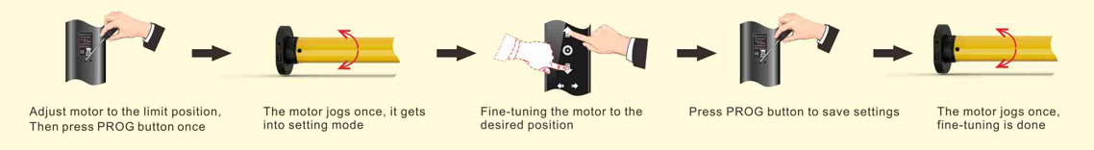
TO DELETE THE LIMIT POSITIONS
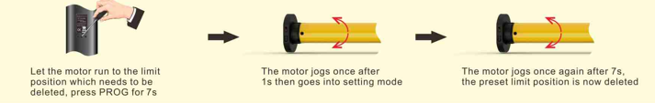

TO RESET YOUR MOTOR TO ERASE ALL SETTINGS
Caution: This will set the motor back to “new” settings and all memory will be erased, including your pairing to your remote and your upper and lower limits!!
Make sure that the interval between every action is less than 1 second.
Follow the steps below:
Press Stop | Motor jogs once | Press back PROG | Motor jogs | Motor jogs two more
Button for |  | Button for 7 | One time in one | Times in 7 seconds
5 seconds |  | Seconds within | second | The reset is
 |  | 10 seconds |  | complete

USEFUL INFORMATION:
- The upper and lower limit position can only be fine-tuned once set. It can only be removed by resetting the motor back to ‘new’ settings.
- Press the UP or DOWN button once and the motor will move to the next limit position. When the upper position has been reached, the Up button will be unresponsive. When the lower position has been reached, the Down button will be unresponsive.
- If the battery is low to 6.2V, the red light on the motor head will flash and motor will switch to jog mode. If low to 5.5V, motor will stop working. Recharge the motor.
- The light turns red during recharging. It will turn green when it is fully recharged.
TROUBLESHOOTING
Item | Problem | Issue | Fix
1 | Motor is not moving or does not work | *Power is off  *Motor unresponsive  *Motor sticking | *Switch motor on by button on motor head  *Charge until motor fully charged  *Make sure all parts are installed properly
2 | Motor stops during operation | *Motor unresponsive  *Protect motor if it encounters an obstacle | *Charge until motor fully charged  *Check if there is something stuck or overloading

