Installation Instructions for Adagio Brand Roller Solar Shades

Product View

Roller Solar Shade with Fascia
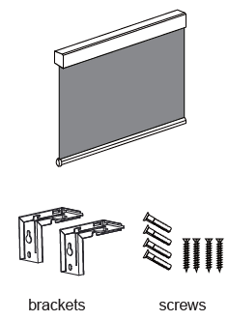

Tools Needed
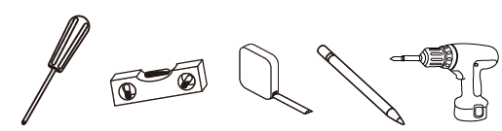
Screw Driver Level Measuring Tape Pencil Power Drill

Installation Step by Step

Please ensure the brackets are installed correctly.
It is very important that the brackets are installed level. A level shade will ensure the shade lifts and lowers properly and rolls straight.
Measure the width of the valance. Mark the positions of the brackets – one bracket 3 to 4 inches from each end, then the remaining brackets spaced evenly between these two.
For inside or outside mount shades, hold the bracket in position and use the holes in the brackets to mark the drill site.
Secure the brackets using these marks for guidance with the screws provided.

For inside mount see the illustration below on bracket and screw placement:
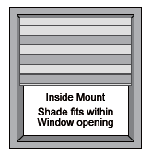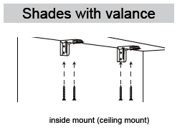
For outside mount see the illustration below on bracket and screw placement:
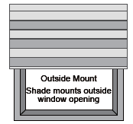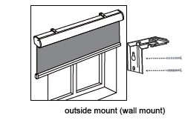
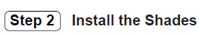
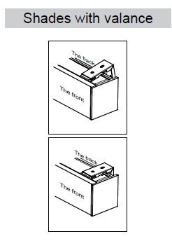
On top of the valance there are parallel overhangs running the width of the shade creating two continuous cavities front and back.
The brackets have a spring-loaded white polycarbonate section on the front plus two small metal hooks underneath midway back.
Hold the valance firmly. Place the front lip of all the brackets under the front cavity on top of the shade. The white polycarbonate pieces will slide under the edge and into the cavity. Adjust the shade left or right to fit perfectly with the opening.
Push the valance towards the wall. This will compress the spring loaded pieces. Rotate the valance up until the top edge makes contact with the bottom of the bracket. Release the pressure while firmly maintaining contact between the top of the valance and the bottom of the bracket. The spring-loaded pieces will push the valance away from the wall allowing the small teeth on the bracket to slide under the back cavity and secure the shade.

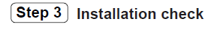
- Make sure the fabric is centered on the tube and rolls off the back side of the shade.
- Ensure the shade is completely level and horizontal
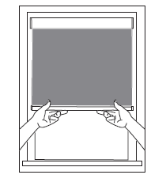

Removing Valance From The Brackets
If you find it necessary to uninstall your shade follow these instructions:

Hold the valance firmly. Push the valance forward to compress the spring-loaded pieces in the brackets, this will release the teeth from under the back cavity, then rotate the back of the shade down. Lift off the front of the brackets.
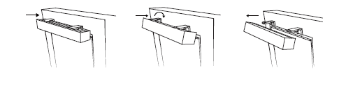
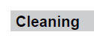
Always clean with a low suction, hand-held vacuum or with a soft, clean cloth or feather duster. For dirt and stains, use a cloth, sponge or soft brush and mild detergent.

